# Automatic Refill Program: California Regulatory Changes to Medication Exclusions Job Aid

California Regulatory Changes: Automatic Refill Program (ARP) Enrollment Consent

Member Education Need: ARP Enrollment Consent

FAQs

Related Documents

**Description:** Information regarding California Board of Pharmacy regulations that require members to consent to enrollment in Automatic Refill Program (ARP) for each prescription each year.

|  |
| --- |
| California Regulatory Changes: Automatic Refill Program (ARP) Enrollment Consent |

* The state of California (CA) requires all pharmacies to maintain annual member consent for medications enrolled into automatic refill/renewal programs.
* This regulation will cause member disruption for orders being shipped to the state of CA (California).
* Initial enrollment of the prescription (Rx) satisfies the consent requirement for the first year (365 days).
* Medications enrolled in ARP less than one (1) year: ARP orders will ship automatically, just as they do today.
* Medications enrolled in ARP greater than one (1) year: Members will need to re-consent prior to any orders being shipped automatically beyond the one (1) year limit.
* Consent is provided at the individual medication level.

**Why:**

This change in program operations is to allow the Caremark Mail Service Pharmacy to remain compliant with California pharmacy regulations.

**When:**

The change was implemented on October 2024.

**Member Communications:**

Members will receive a communication informing them that their Rx has been disenrolled from ARP. Members will receive a letter, email, or SMS text message depending on their message preferences.

Communications will encourage members to re-enroll their Rx in ARP to continue receiving orders automatically. **Examples:**



**SMS Text Message Communication**

**Email Communication**

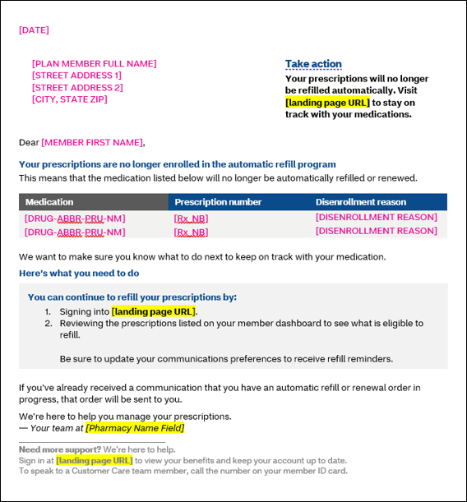

**Printed Letter Communication**

**Care Agent Experience:**

Care agents are able to see an Rx-level comment in system: “Rx disenrolled due to state regulations. Member must re-enroll to continue receiving automatic refills.“

 Do not provide a phone number or encourage the member to contact the Board of Pharmacy.

**Workflow Examples:**

Refer to the table below:

|  |  |
| --- | --- |
| **Scenario** | **Action** |
| Member living in California | * July 1, 2024: Member enrolls Rx with 3 refills into ARP. * September 2024: First refill order processes automatically and ships to CA. * December 2024: Second refill order processes automatically and ships to CA. * March 2025: Third refill order processes automatically (zero refills remain) and ships to CA. * July 15, 2025: LINKS triggers renewal order and new Rx received from the physician. * July 15, 2025: LINKS determines that order will process and ship to CA outside of 365-day consent window.   + Rx disenrolled from ARP.   + Member sent a communication that tells them to re-enroll to continue receiving automatic orders.     - If member re-enrolls: Re-enrollment = consent for another 365 days.     - If member does not re-enroll: Member will need refill their Rx “manually” via the mail pharmacy. |
| Member with temporary address in California and Medication enrolled greater than 1 year | * July 1, 2024: Member living in Illinois (IL) enrolls Rx with 3 refills into ARP. * September 2024: First refill order processes automatically and ships to IL. * December 2024: Second refill order processes automatically and ships to IL. * March 2025: Third refill order processes automatically (zero refills remain) and ships to IL. * April 2025: Member adds temporary address in CA to be used between 4/15/2025 - 9/1/2025. * July 15, 2025: LINKS triggers renewal order and new Rx received from the physician. * July 15, 2025: LINKS determines that order will process and ship to CA outside of 365-day consent window.   + Rx disenrolled from ARP.   + Member sent a communication that tells them to re-enroll to continue receiving automatic orders.     - If member re-enrolls: Re-enrollment = consent for another 365 days.     - If member does not re-enroll: Member will need refill their Rx “manually” via the mail pharmacy. |
| Member with temporary address in California and medication enrolled less than 1 year | * July 1, 2024: Member living in Illinois (IL) enrolls Rx with 3 refills into ARP. * September 2024: First refill order processes automatically and ships to IL. * October 2024: Member adds temporary address in CA to be used between 11/1/2024 - 1/15/2025. * December 2024: Second refill order processes automatically and ships to CA. * March 2025: Third refill order processes automatically (zero refills remain) and ships to IL. * July 2025: LINKS triggers renewal order and new Rx received from the physician. * July 2025: Renewal order shipped automatically to IL. |

Top of the Document

|  |
| --- |
| Member Education Need: ARP Enrollment Consent |

**What:**

* The state of California (CA) requires member consent to contact the prescriber for a new Rx.
* Website ARP enrollment language was updated to make it clear that opting into the program allows the mail pharmacy to contact prescribers when the Rx is up for renewal.

**Need:**

Agents need to remind members that enrolling in ARP means that Caremark will contact their physician when their Rx(s) expires or runs out of refills.

Top of the Document

|  |
| --- |
| FAQs |

Refer to the table below:

|  |  |  |
| --- | --- | --- |
| **#** | **Question** | **Answer** |
| **1** | Will the California members be blocked from adding the ARP back to their profiles on Caremark.com? | No, members will be encouraged in communications to re-enroll their Rx into ARP via the website |
| **2** | Will the California members be provided with a phone number for complaints to the CA Board of pharmacy (BOP) to make a complaint about this change? | No. If a member asks why this change is being made, we can tell them it is in response to the CA Board of Pharmacy. We should not provide a phone number or encourage the member to contact the BOP. |
| **3** | What is the CA Board of Pharmacy? | The California Board of Pharmacy is a regulatory agency that oversees pharmacies operating in the state of California. |
| **4** | Why was this change put in place? | This process was put in place to comply with regulatory requirements. |
| **5** | What are the regulatory requirements? | The Board of Pharmacy for the state of California requires that members provide annual consent on file for their prescription renewal. |
| **6** | Can I opt out of this change? | Unfortunately, members cannot opt out of this change. |
| **7** | I pay for this service with my insurance premium, who authorized this change at the insurance provider? | This change is required to allow the CVS Caremark Mail Serrvice pharmacy to remain compliant with all state board of pharmacy regulations. |
| **8** | Can I contact the California Board of Pharmacy? | That is your choice.  Do not provide a phone number or encourage the member to contact the Board of Pharmacy. |
| **9** | Do you recommend that I contact the CA BOP? | That is your choice.  Do not provide a phone number or encourage the member to contact the Board of Pharmacy. |
| **10** | Can you provide the contact info for the CA BOP? | We do not have that info on file.  Do not provide a phone number or encourage the member to contact the Board of Pharmacy. |

Top of the Document

|  |
| --- |
| Related Documents |

[Customer Care Abbreviations, Definitions, and Terms Index (017428)](https://thesource.cvshealth.com/nuxeo/thesource/#!/view?docid=c1f1028b-e42c-4b4f-a4cf-cc0b42c91606)

Top of the Document

Not to Be Reproduced or Disclosed to Others Without Prior Written Approval

**ELECTRONIC DATA = OFFICIAL VERSION / PAPER COPY = INFORMATIONAL ONLY**